1.Create numeric, character, and logical vectors and display type and content.

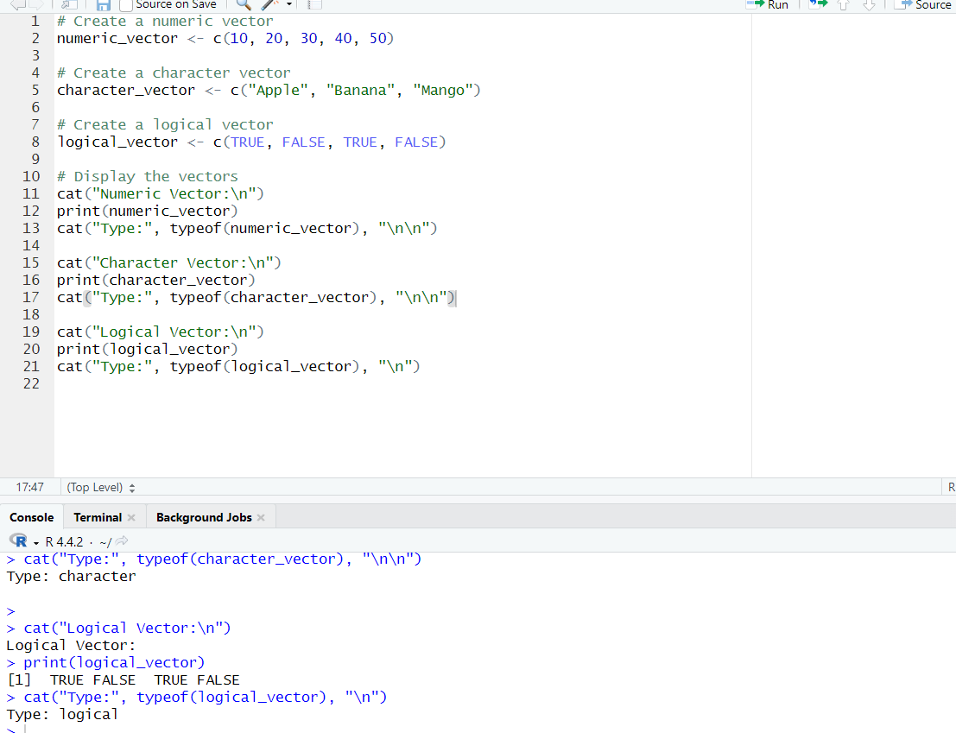

2.Create labeled matrices (5×4, 3×3, 2×2) filled by row/column.
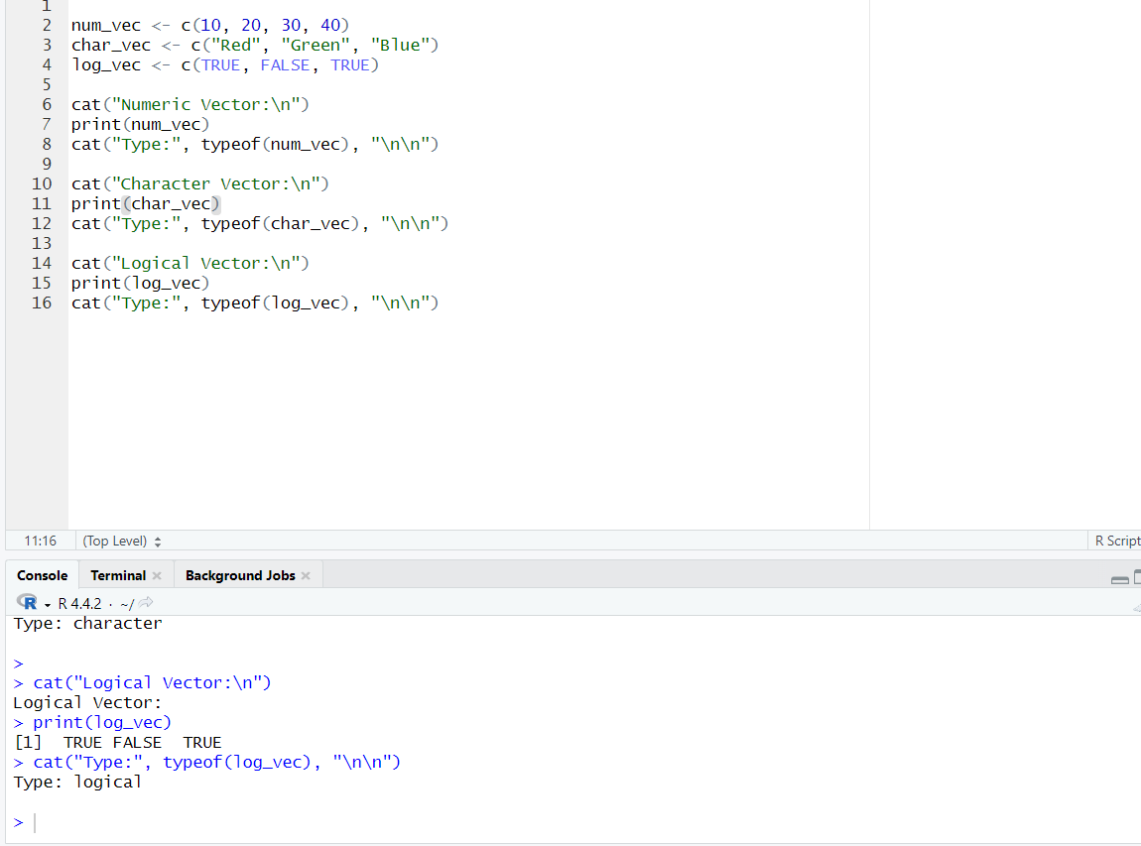

3.Write an R program to create and display a 3D array with specified rows, columns, and tables.
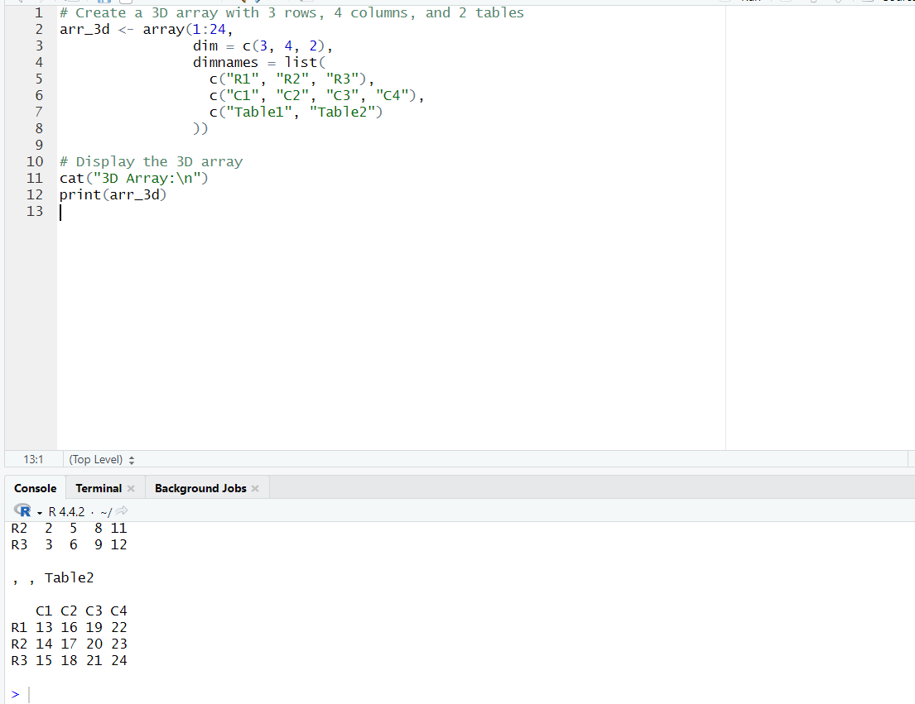

4.Create arrays from vectors with dimension names, print specific elements.

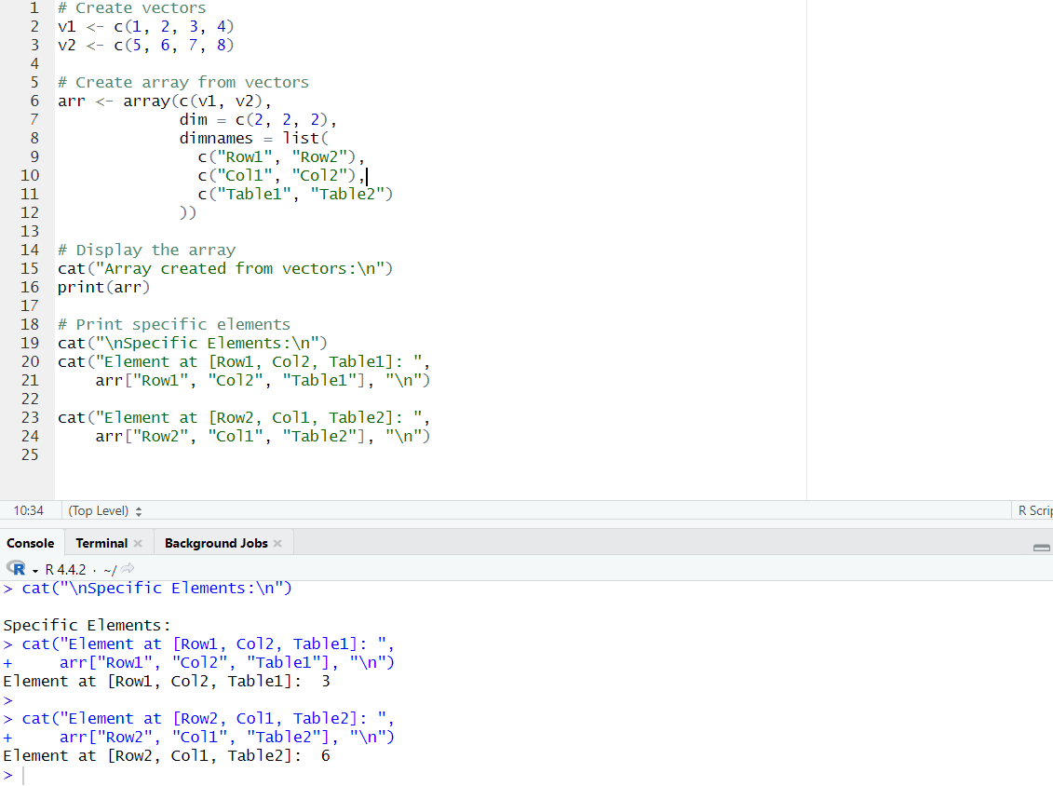

5.Create and manipulate factor variables (e.g., women’s dataset heights, random LETTERS sample).

